Yugansh Tripathi
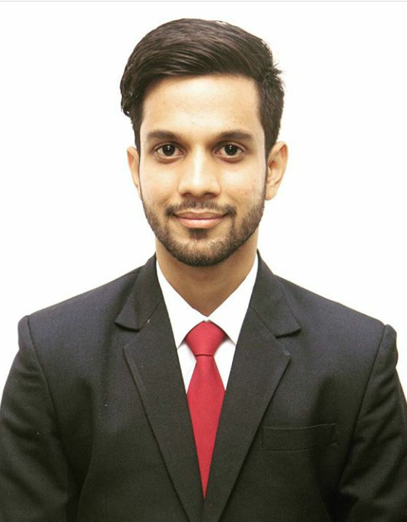

Citizenship: Indian
Date of Birth: 21 March, 1995
Language Proficiency: English & Hindi
Mobile: +91 9004985120
Email: yugansh21@gmail.com

Objective

Looking for a challenging opportunity to gain valuable exposure in industry and explore my skill sets and knowledge, to effectively deliver assigned responsibilities and contribute to organizational growth along with personal development.

Academic Profile

Year(s) | Qualification - Degree/Diploma/ Certificate | Board/  University | College/Institute | Percentage
2016-2018 | P.G.D.M (Finance + Marketing) | AICTE | Institute of Management Development & Research,  Pune. | 61.30%
2013-2016 | Bachelors’ in Commerce | Lucknow University | Lucknow Christian Degree College,  Lucknow. | 51.30%
2012-2013 | XII | ISC | Modern School,  Lucknow. | 81%
2010-2011 | X | ICSE | Modern School,  Lucknow. | 82%

wORK EXPERIENCE

- Bajaj Finance
  - Duration : May,2018–Mar,2019
  - Designation : Manager: Underwriting (Business Loans)
- Work Profile: Loans Underwriting. Determining the creditworthiness of Business, and taking decisions regarding sanctioning/rejecting loan applications.
- Underwriting loan applications.
- Credit Analysis/Financial Analysis
- Writing Credit Reports
- Providing Quantitative and Qualitative Content Reports to concerned departments.
- Primary & Secondary Research about Business Profile, Credit structure, repayment trends and utilization of funds.
- Customer Servicing: Assisting customer in use of various products and utilization of facilities.
- Assisting Collections team in recovery from defaulting customer.

PROJECTSAND INTERNSHIPS UNDERTAKEN

- Axis Bank, Lucknow
  - Duration: 8 weeks (May -June, 2017)
  - Work Profile: Branch Operations- Trainee.
  - Role & Responsibilities:
- Handling Money Transfer/Settlement Process
- Accepting Cheque Deposits/ Withdrawal
- Cross Selling- 4-wheeler Auto insurance & Atal Pension Yojna (Investment)
- Customer Servicing
- Other Front Office Operations.
- Customer Satisfaction Research Survey

Research Project: “A Study: Financial Statement Analysis of Axis Bank for FY 2016/17 & Customer Satisfaction for Indiranagar Branch, Lucknow.”

- “A Study on Impact of recognized Brand Ambassador of Sports brands on buying behavior of Customers.”, Pune. (Winter Research Project- IMDR, Pune)

KEY SKILLS

- Content Creation, Development & Improvisation
- Quantitative Research & Qualitative Research
- Good communication & interpersonal skills
- Comfortable in working on MS Office. (Excel, PowerPoint, Word, Outlook)
- Financial/Credit Analysis
- Analytical skills
- Good Team player
- Compliant
- Emphatic

ACADEMIC / EXTRA-CURRICULAR ACHIEVEMENTS

- Content Writing
- Blogging (Sports/Spirituality/Entertainment)
- Represented Cricket teams at School/College, Club & District level Professional Cricket Competitions.
- Drama: Winner of various plays/drama competitions during School & College.
- Part of the survey team for a research project on “Impact of Demonetization on Rural sector with special reference to Pune.”
- Member of Sports Committee during PGDM at IMDR. (2016-18)
- Winner at various LAN Gaming Events at school/college level.

WORK PORTFOLIO

- https://mysportsscript.wordpress.com/
- https://thestoryreviews.wordpress.com/
- https://yugsays.wordpress.coms

